**Steps to create Function Module**

1. Go to code se37

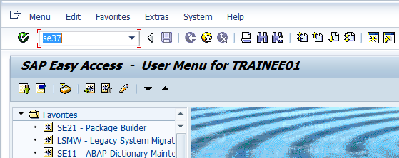

1. Give a Function Module name starting with Z or Y (E.g., ZFM_add) and press on Create button

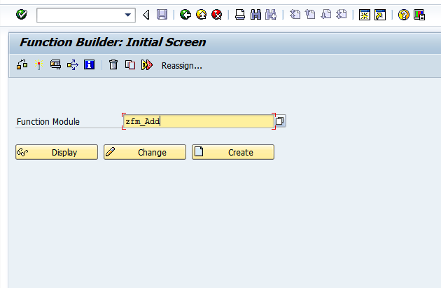

1. Give a Function Group name created earlier (ZFG_RTC) and give a short description for the FM and click on Save.

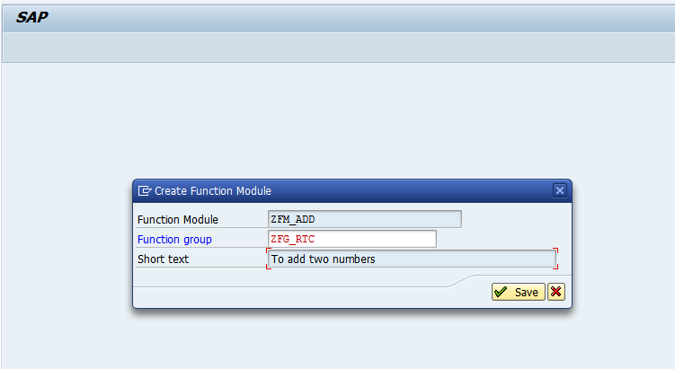

1. In the import tab, enter two parameters num1 and num2 of type i.

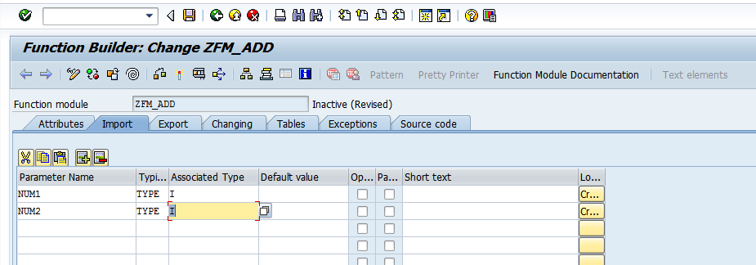

1. In the export parameter, enter the output parameter ‘Result’ of type i.

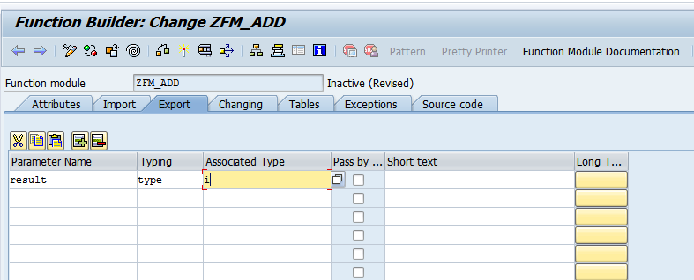

1. In the tab Source code, enter the below logic

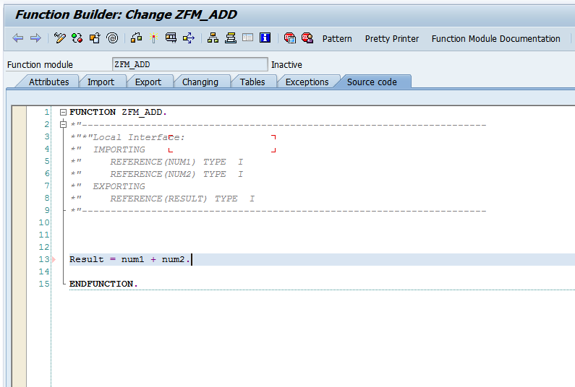

6. Save and activate the FM. Your function module is created and ready for use